pleasantville ayso Blue sombrero guide : How to bulk email

Introduction
In Summer 2017 AYSO nationally adopted the blue sombrero product to act as a registration/team management/ admin portal. As of fall 2017 there are still a number of non-intuitive functions in that portal and a series of how to guides is being produced to help users navigate the noise.
This document focuses on sending email form the system

basic Setup
In order to send emails form the system you need to have the Newsletter role assigned to your profile, this can only be assigned by a site admin.
Once you have this role you should see a new option at the top of your screen:
Click on this and move on to the next section

How to send an email
What you want to do is send a Bulk email so make sure that’s selected up top then you have to navigate the fields of confusion :

Select Group
This has a drop down of the following :
  - Programs : There is only one program and this is what to use to mail everyone participating!
  - Divisions : Division coordinators should use this as it targets your specific division
  - Teams : allows specific targeting of teams – Team Head coaches could use this , however the discussion board is the preferred team communication method
  - Volunteer Roles : Used by the RC and other Admins to target specific roles. Division Coordinators can also use this, see note below on groups.
  - Open Orders : RC specific list for targeting people who did not complete checkout.
  - Overdue installments : Not valid for Pleasantville
  - Wait List : Not Valid for Pleasantville
  - All active users – this targets all users of the system, not just participants ((a) just targets participants)
  - Users : allows targeting of individual users
  - Roles : Allows targeting of roles such as Division Coordinator
  - Shopping Cart Orders : Specific subset of (e)
  - Archived Programs : Previous Years (a)
  - Archived Divisions : Previous Years (b)
  - Custom Groups : See note below – you can setup a custom group
  - Verified/Unverified Players and Volunteers : RC specific list for targeting unverified participants

Email Groups
Under the email groups section you will see different options , based on the group you selected , the most common thing you will see is something like this :
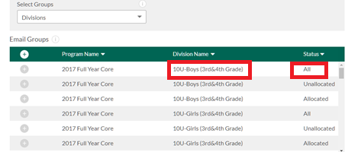
Make sure you get the Division Name correct and that you select All , we will not use the Allocated/Unallocated lists at this time.
Once you have identified the correct group click on the + button to the left and you should see it added to the Recipients area of the screen.
Additional Recipients can be added in the free text box on the right of the screen. Do not remove the default ayso@pvillesoccer.com email address.

Email options
When you come to write the email there are a couple of things to change :
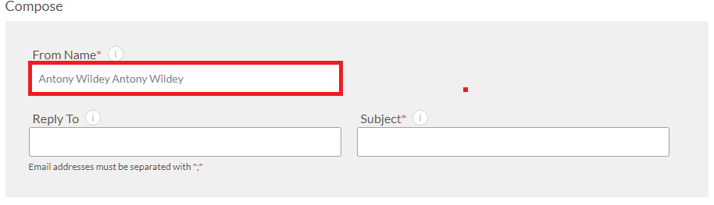
From Name is defaulting incorrectly please use the following format for from name until the defaulting is fixed:
Pleasantville AYSO (<Your Role>) e.g. Pleasantville AYSO (U12B Division Coordinator)
Reply To : I suggest setting this to your personal email you use for AYSO communications
Subject : Prefix this with your division e.g. U12B – Some Text

Templates
You can create Templates from an existing Template, this makes your email look nice and prevents you having to retype a lot. When using templates please :
- Do not amend someone else’s template
- Name your Template with the Division Prefix if appropriate
- Don’t create a thousand Templates
- Remember that Templates are shared

The last Bit
Once done writing your email, preview it and then click on send now to immediately send it out.
Please be cautious about spamming everyone and as there are no permissions around emailing only your own group make sure you are targeting the correct list.

